UNIX PROGRAMMING – ASSIGNMENT 6
SUBMITTED BY – NISARGA VISHWAMANJUSWAMY

- Chapter 2, do exploration 2.3 on page 68.

Steps:
- Creating a new file named cp1.c - vi cp1.c
- Compile – gcc -o cp1 cp1.c
- Copy file cp1.c to the terminal - ./cp1 source.txt /dev/tty
- Copy from terminal to a file - ./cp1 /dev/tty output.txt
- Type the input statements press enter then ctrl-D
- View output.txt – to check whether the content we have typed is reflecting or not.

cp1.c
#include <stdio.h>
#include <unistd.h>
#include <fcntl.h>
#include <stdlib.h>
#include <string.h>

#define BUFFERSIZE 4096
#define COPYMODE 0644

void oops(char *s1, char *s2);

int main(int ac, char *av[]) {
int in_fd, out_fd, n_chars;
char buf[BUFFERSIZE];

if (ac != 3) {
fprintf(stderr, "usage: %s source destination\n", av[0]);
exit(1);
}

if ((in_fd = open(av[1], O_RDONLY)) == -1)
oops("Cannot open", av[1]);

if ((out_fd = creat(av[2], COPYMODE)) == -1)
oops("Cannot create", av[2]);

while ((n_chars = read(in_fd, buf, BUFFERSIZE)) > 0) {
if (write(out_fd, buf, n_chars) != n_chars)
oops("Write error to", av[2]);
}
if (n_chars == -1)
oops("Read error from", av[1]);

if (close(in_fd) == -1 || close(out_fd) == -1)
oops("Error closing files", "");

return 0;
}

void oops(char *s1, char *s2) {
fprintf(stderr, "Error: %s: %s\n", s1, s2);
perror(s2);
exit(1);
}
OUTPUT:
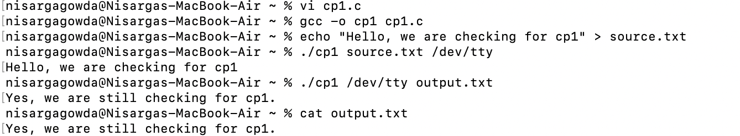
- Chapter 2, do programming exercise 2.15 on page 70.
Steps:
- Create a file named cp1.c – vi cp1.c
- Compile the file – gcc -o cp1 cp1.c
- Copy the file - ./cp1 source.txt dest.txt
- We’ll be prompted with mesaage - File destination.txt already exists. Overwrite? (y/n):
- Now we can make selection y/n accordingly.

cp1.c
#include <stdio.h>
#include <unistd.h>
#include <fcntl.h>
#include <stdlib.h>
#include <string.h>
#include <sys/stat.h>
#define BUFFERSIZE 4096
#define COPYMODE 0644

void oops (char *, char *);

int main (int ac, char *av[]) {
int in_fd, out_fd, n_chars;
char buf[BUFFERSIZE];
if (ac != 3) {
fprintf(stderr, "usage: %s source destination\n", *av);
exit(1);
}

struct stat st;
if (stat(av[2], &st) == 0) {
char response;
printf("Destination file %s exists. Overwrite? (y/n): ", av[2]);
response = getchar();
if (response != 'y' && response != 'Y') {
printf("Copy operation aborted.\n");
exit(0);
}
while (getchar() != '\n');
}

if ((in_fd = open(av[1], O_RDONLY)) == -1)
oops("Cannot open ", av[1]);

if ((out_fd = creat(av[2], COPYMODE)) == -1)
oops("Cannot create ", av[2]);

while ((n_chars = read(in_fd, buf, BUFFERSIZE)) > 0) {
if (write(out_fd, buf, n_chars) != n_chars)
oops("Write error to ", av[2]);
}
if (n_chars == -1)
oops("Read error from ", av[1]);

if (close(in_fd) == -1 || close(out_fd) == -1)
oops("Error closing files", "");

return 0;
}

void oops (char *s1, char *s2) {
fprintf(stderr, "Error: %s", s1);
perror(s2);
exit(1);
}

OUTPUT:
